**Comp1168 LabNo5**

Name: Wong, Jui Hsin

CRN: 50138

Student Id: 101559700

Date: 02/11/2025

* Q1

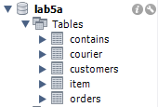

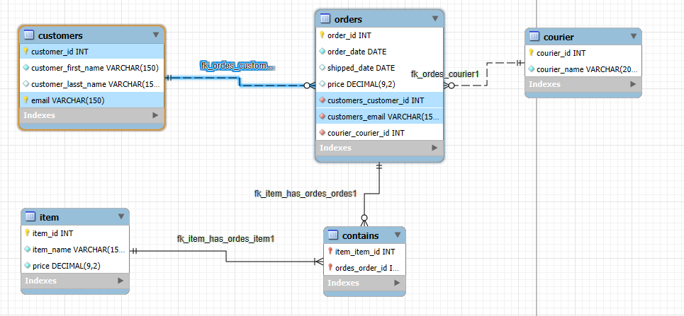

* Q2
* Q3